Design Doc:

Here is an example of heatmap that is similar to the one I am trying to create. I would like it to have an option to select data by province, county and specific area in a county. I would like it to have drop down menus to select these options as well as being able to select on the map itself.

I would like the legend for the colour scheme of the heatmap to be on the left side of the country map like this.

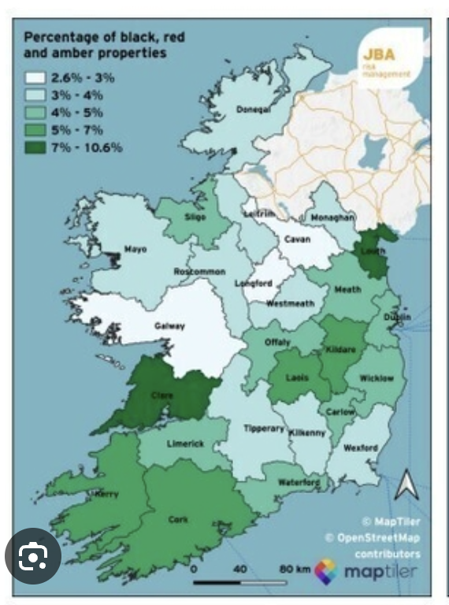

I like the colour scheme of this for the heatmap, with yellow having the least amount of data points and purple is data heavy



I like this font, use this throughout the website


Here is an example of a website that we like the user interface of: https://trends.google.com/trends/?utm_source=chatgpt.com

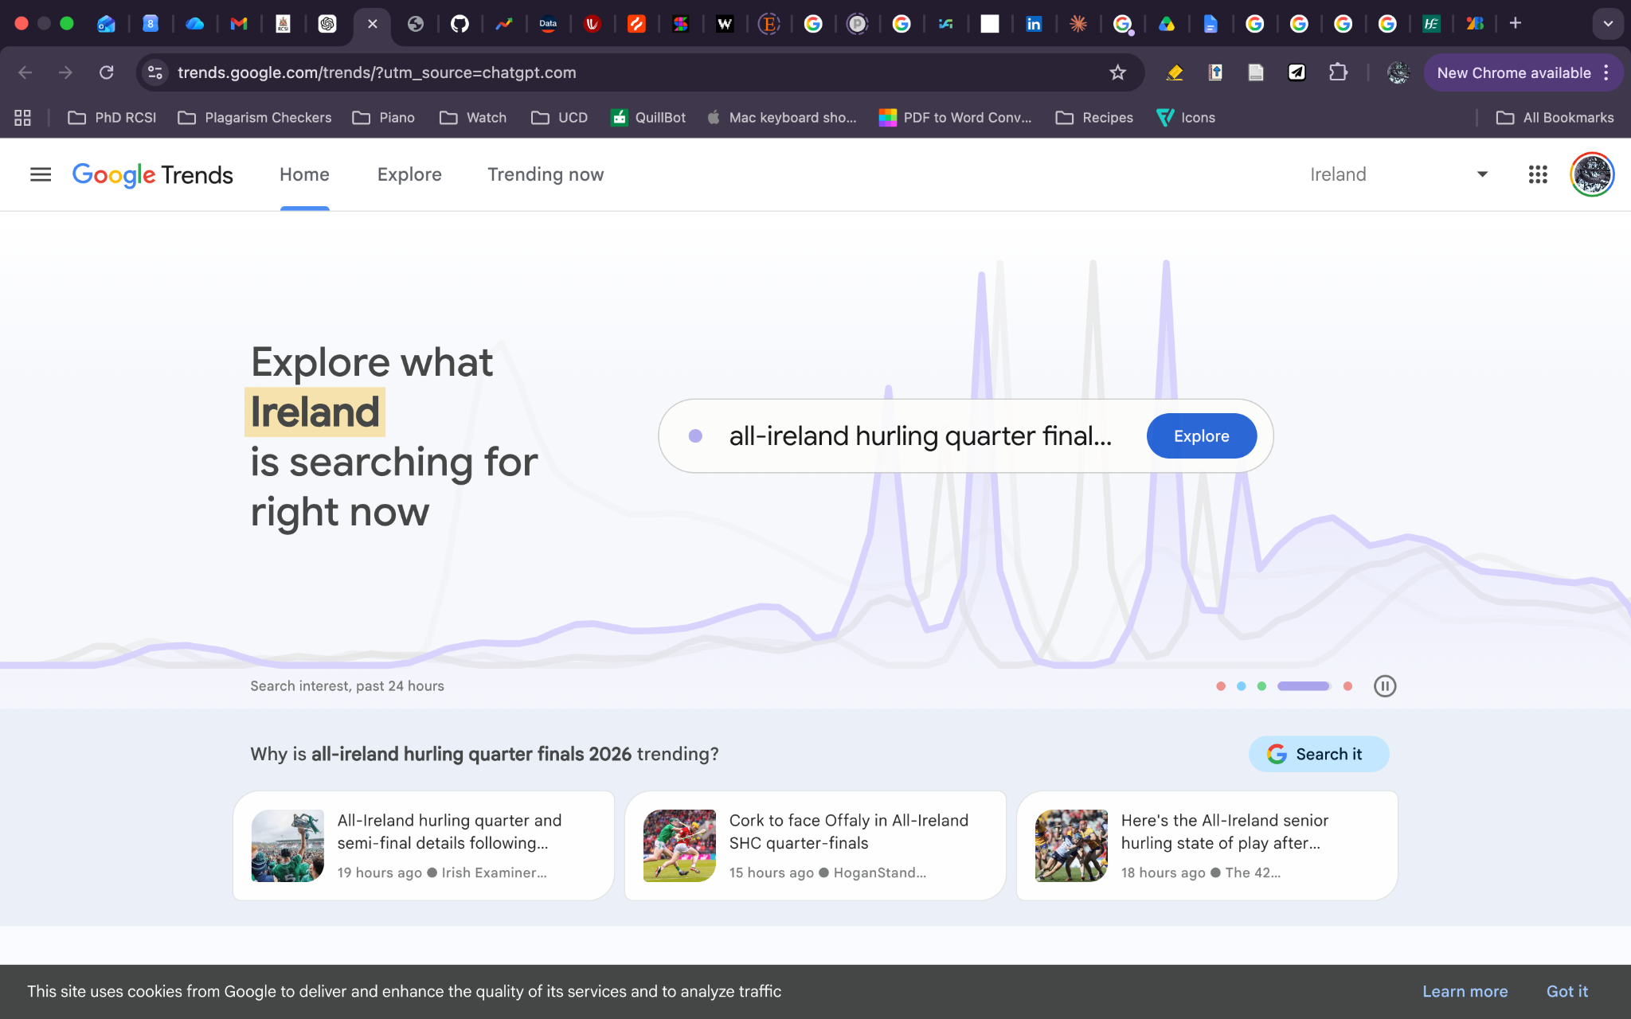

We would like there to be a welcome/home page to explain what the website is for and what data we are presenting. We would then like there to be another tab where you can click onto the heatmap.

On the heatmap page, I would like you to be able to navigate the map by clicking on the map itself but also by using dropdown menus (eg. county, town etc)

